Network Traffic Analysis Report

Wireshark Network Traffic Inspection & Protocol Analysis

Brief Description
This project focuses on analyzing live network traffic using Wireshark. Captured network packets were inspected to identify various communication protocols, broadcast traffic, multicast DNS (mDNS) activity, ARP requests, and IPv6 router advertisements.
The analysis provides insights into how devices communicate within a local network environment and helps identify potential security observations related to service discovery, network exposure, and protocol behavior.

Detailed Packet Analysis
Tool Used
- Wireshark

Observed Protocols The packet capture contains multiple network protocols:
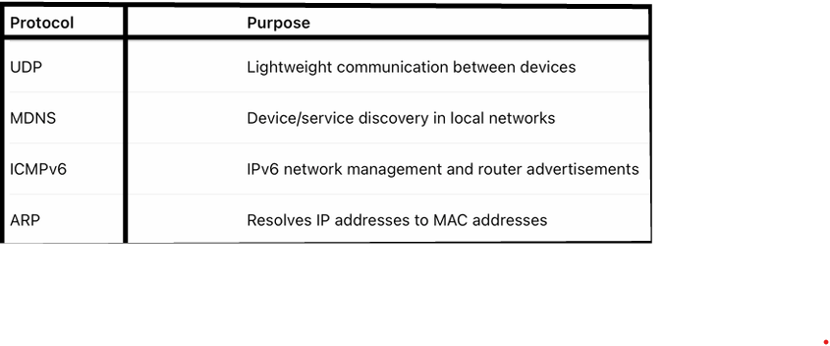

Key Findings from the Capture
1. Multicast DNS (mDNS) Traffic Detected
Several captured packets contained the following query:
Standard query PTR _spotify-connect._tcp.local
Analysis
The captured traffic indicates that devices on the network were searching for Spotify Connect-enabled devices using the Multicast DNS (mDNS) protocol.
mDNS operates using multicast addresses such as:
- IPv4: 224.0.0.251
- IPv6: ff02::fb
This protocol is commonly used for local service discovery by devices such as:
- Smart TVs
- Wireless speakers
- Chromecast devices
- IoT and smart home devices
Security Observation
Excessive mDNS traffic may expose device names, host information, and available services to other users connected to the same network. On public or shared networks, attackers may use mDNS traffic to enumerate devices and identify accessible services.
Risk Level
Low
Recommended Remediation
- Disable unnecessary service discovery features when not required.
- Avoid connecting sensitive or personal devices to public Wi-Fi networks.
- Use network segmentation to isolate IoT and smart devices from critical systems.
- Restrict multicast traffic where possible through network configuration policies.
2. Google Cast / Chromecast Discovery
Captured packets contained the following service discovery query:
_googlecast._tcp.local
Analysis
The presence of this traffic indicates the discovery of Chromecast or Google Cast-enabled devices on the local network. These devices use mDNS to broadcast their availability and enable nearby devices to detect and connect for media casting services.
Security Concern
Exposed casting devices on insecure or shared networks may allow unauthorized users to discover available smart devices. Attackers may use this information to identify devices for further reconnaissance or targeted attacks.
Risk Level
Low to Medium
Recommended Remediation
- Place smart devices on separate VLANs or guest networks.
- Disable casting and discovery features when not required.
- Keep device firmware and software updated with the latest security patches.
- Restrict unnecessary multicast and service discovery traffic where possible.

3. ICMPv6 Router Advertisement Messages
Observed Packet
ICMPv6 Router Advertisement
Analysis
ICMPv6 Router Advertisement (RA) messages are used by IPv6 routers to periodically advertise network configuration information to devices on the network. These messages help devices automatically configure IPv6 addresses and discover default gateways without manual configuration.
This process is part of IPv6 Stateless Address Autoconfiguration (SLAAC), which enables seamless network connectivity in IPv6 environments.
Security Concern
Malicious ICMPv6 Router Advertisement messages can potentially be abused for attacks such as:
- Rogue router attacks
- Man-in-the-middle (MITM) attacks
- Traffic redirection attacks
Risk Level
Medium
Recommended Remediation
- Enable RA Guard on managed network switches to block unauthorized router advertisements.
- Disable unused IPv6 services if IPv6 is not required in the environment.
- Monitor the network for unusual or unexpected router advertisement behavior.
- Implement network monitoring and intrusion detection mechanisms for IPv6 traffic.

4. ARP Communication Detected
Observed Entry
ARP 192.168.0.1 is at 54:af:97:2c:dd:79
Analysis
Address Resolution Protocol (ARP) is used within local networks to map IP addresses to MAC addresses. This behavior is considered normal for device communication in IPv4-based local area networks.
Security Concern
ARP traffic may be exploited in attacks such as:
- ARP spoofing
- Man-in-the-middle (MITM) attacks
- Network interception and packet sniffing
Attackers may send forged ARP responses to redirect network traffic through malicious systems.
Risk Level
Medium
Recommended Remediation
- Enable Dynamic ARP Inspection (DAI) on managed switches.
- Use HTTPS and encrypted communication protocols to protect sensitive data.
- Monitor for duplicate or suspicious ARP responses on the network.
- Implement network segmentation and access control policies where possible.
5. Broadcast Traffic Observed
Example
Destination: 192.168.0.255
Analysis
Broadcast packets are transmitted to all devices within the local subnet. This type of communication is commonly used by network discovery protocols and local communication services to identify devices and share network-related information.
Security Concern
Excessive broadcast traffic may:
- Increase unnecessary network traffic and congestion
- Reveal active devices present on the network
- Assist attackers in performing network reconnaissance and device enumeration
Although broadcast traffic is generally normal in local networks, unusually high volumes may indicate misconfigurations or suspicious network activity.
Risk Level
Low
Recommended Remediation
- Disable unnecessary discovery and broadcast-based services when not required.
- Segment large networks to reduce broadcast domains and network noise.
- Continuously monitor the network for abnormal spikes in broadcast traffic.
- Implement proper network monitoring and intrusion detection solutions.
Overall Security Assessment
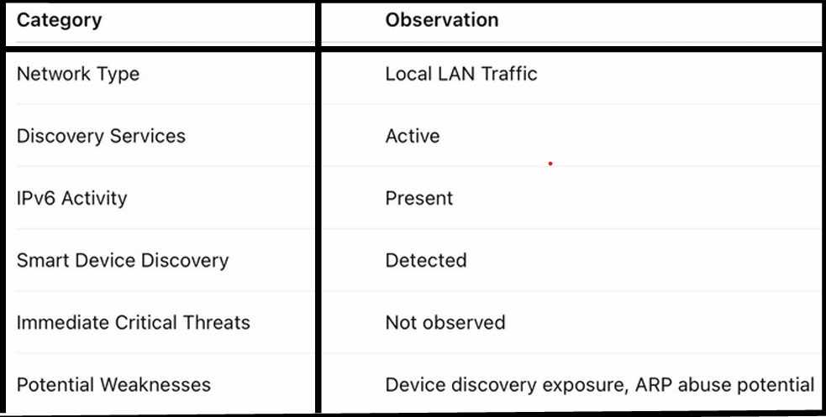
Wireshark Network Traffic Capture
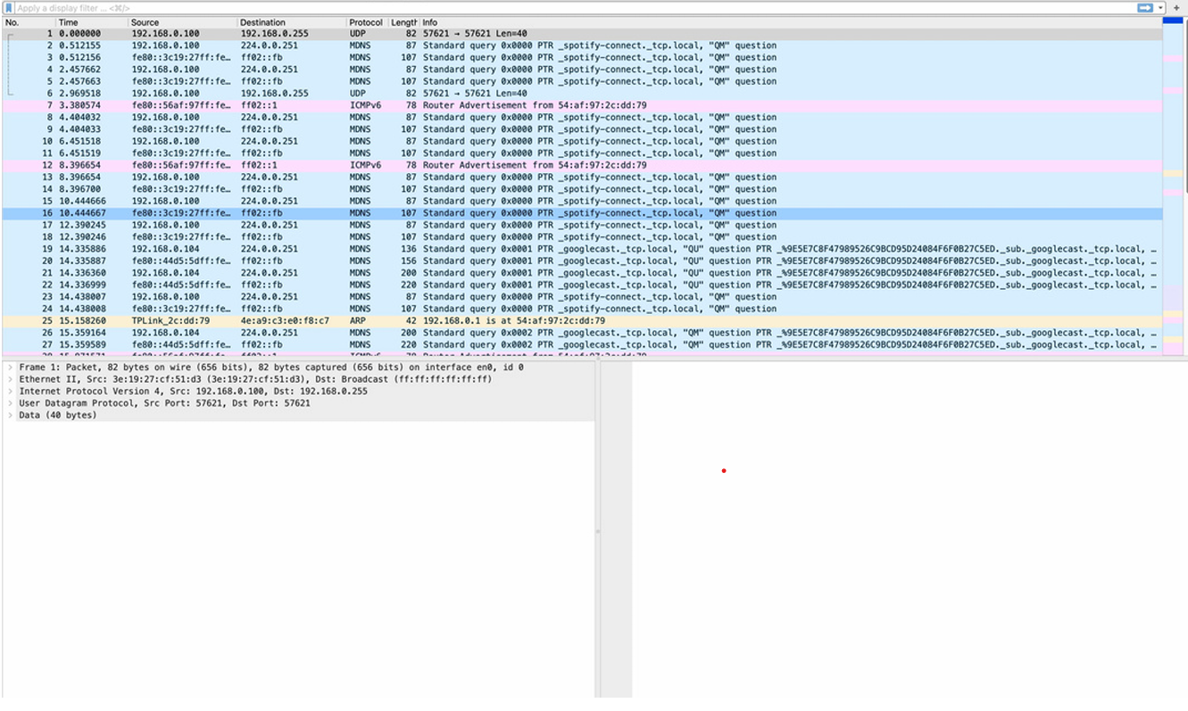
Final Conclusion
The captured network traffic primarily represents normal local network activity involving service discovery, router advertisements, broadcast communication, and address resolution protocols. No direct malicious activity was identified during the analysis. However, the captured traffic highlights several areas that could potentially be exploited by attackers in unsecured or public network environments.
The project demonstrates practical knowledge and hands-on skills in:
- Packet inspection
- Protocol analysis
- Network traffic monitoring
- Security risk identification
- Understanding network reconnaissance techniques
Overall, this analysis improves understanding of how devices communicate within a local network and how commonly used network protocols may be leveraged by attackers for reconnaissance, traffic interception, or unauthorized network discovery.

